**Project Report**

**On**

**HOSPITAL**

**Management**

**System**

**Submitted By:**

* **Saurabh Kale.**
* **Ajit Deshmukh.**
* **Shubhang Joshi.**

**CERTIFICATE**

*Certified that this is a bonafide record of the project work titled*

*HOSPITAL MANAGEMENT SYSTEM*

*Done By:*

***Saurabh Kale.***

***Ajit Deshmukh.***

***Shubhang Joshi.***

*has successfully completed the* ***Database Management system Mini Project*** *in the institute during the period from 2021 to 2022.*

*Project guide Head Of Department*

***Prof.Nehali Shinde. Prof.Rahul Ghode***

**TABLE OF CONTENTS**

* ABSTRACT
* INTRODUCTION
* PROJECT AIMS AND OBJECTIVES
* BACKGROUND OF PROJECT

## **HOSPITAL MANAGEMENT SYSTEM PROJECT PROPOSAL**

* [HOSPITAL MANAGEMENT SYSTEM DATABASE DESIGN](https://itsourcecode.com/vb-net/hospital-management-system-database-design/)
* [**HOSPITAL MANAGEMENT SYSTEM CLASS DIAGRAM**](https://itsourcecode.com/uml/hospital-management-system-class-diagram-uml/)
* [**HOSPITAL MANAGEMENT SYSTEM ER DIAGRAM**](https://itsourcecode.com/uml/hospital-management-system-class-diagram-uml/)
* SOFTWARE AND HARDWARE REQUIREMENTS
* CONCLUSION
* FUTURE SCOPE
* REFERENCES

**Abstract:**

This Hospital Management System project is a computerized hospital front desk management that produces user-friendly, quick, and cost-effective software. It handles and secures patient information, diagnosis data, and so on. This was done by hand and its’ principal job is to register and maintain patient information and to access and update the information when needed. Patient information and diagnosis are entered into the system, then the output is used to display these details on the screen.

The information is easily accessible. For personal usage, the data is well-protected, and the data processing is quick.

**INTRODUCTION**

A hospital management system project is a computer system that facilitates the efficient management of healthcare information and the work completion of healthcare providers. This hospital management system project report oversees data from all areas of healthcare.

The hospital management system aids in the registration of complete patient data. It records and retains the patient’s medical history, treatment needs, reports and more. It reduces the requirement for these details to be obtained at each software visit.

**PROJECT AIMS AND OBJECTIVES**

The project aims and objectives that will be achieved after completion of this project are discussed in this subchapter. The aims and objectives are as follows:

* Online Registration of Patient.
* Note the Disease and Other information about Patient.

**BACKGROUND OF PROJECT**

HOSPITAL Management System is an application which refers to Hospital systems . It is used by Hospitals to manage the Patient data using a computerized system. Patient Details maintenance modules are also included in this system.

With this computerized system there will be no loss of Patient record which generally happens when a non computerized system is used. All these modules are able to help Hospital to manage the patient information with more convenience and in a more efficient way.

## ****Hospital Management System Project Proposal****

The **Hospital Management System Project Proposal**has the complete description of the project to be proposed. This contains the problem statement which discusses the difficulties that the hospital management faced and it is considered as the reason why the project is proposed. This proposal also includes the project scope that explains the boundaries and possible features of the project.

**PROBLEM STATEMENT:**

Medical care is one of the most essential and in-demand services for all. It requires a lot of attention and high-quality service that also causes health care workers to do a lot of effort. These issues also add to the situations where there’s a need for a physical attendant for every patient wherein it could be automated and handled with technology.

**SOLUTION:**

To address the issues faced by hospitals, a system named Hospital Management System is proposed. This system will handle information such as patients with mild diagnoses and prescriptions. The idea of having automated patient management is a big help for our health care workers and physicians to monitor and take good care of the patients.

**SCOPE:**

The hospital management system could handle specific tasks such as securing various information of the patients. This will help them secure the data to keep patient-doctor confidentiality as well as assure them of their healing factors. It can also improve the productivity of the health care workers and could let them accommodate more patients.

[**Hospital Management System Database Design**](https://itsourcecode.com/vb-net/hospital-management-system-database-design/)

The *Hospital management system database design* is a database design used for managing **hospital** functions and events. It enables the admin to register a patient for the hospital their disease details into the database. Any of the staff members, doctor & admin is able to add, view, edit, update or delete data.

The purpose of the [Hospital Management System](https://www.ukessays.com/essays/management/hospital-management-system.php) database Design is to make a secure and easy way of storing information of the patient.

[**Hospital Management System Class Diagram**](https://itsourcecode.com/uml/hospital-management-system-class-diagram-uml/)

Is a designed diagram that shows the system’s relationships and classes. This UML Class Diagram is made to guide programmers along with the hospital management system development.

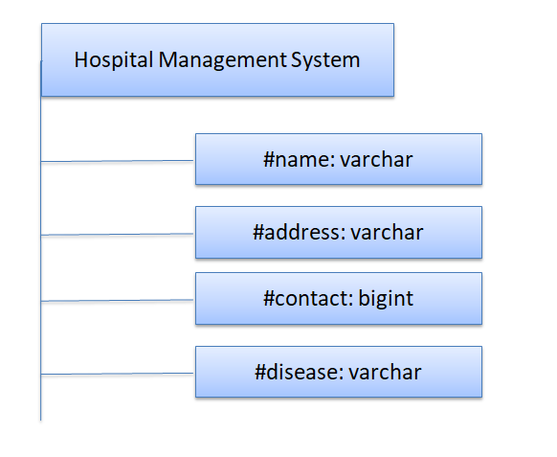

[**Hospital Management System ER Diagram**](https://itsourcecode.com/uml/hospital-management-system-class-diagram-uml/)

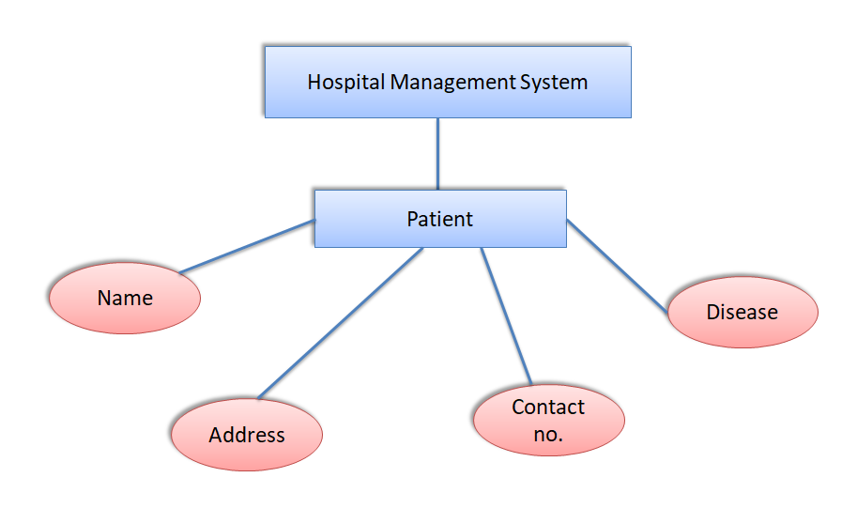

**SOFTWARE AND HARDWARE REQUIREMENTS**

This section describes the software and hardware requirements of the system

**SOFTWARE REQUIREMENTS**

* Operating system- Windows 7 or above is used as the operating system as it is stable and supports more features and is more user friendly
* Database MYSQL-MYSQL is used as database as it easy to maintain and retrieve records by simple queries which are in English language which are easy to understand and easy to write.
* Development tools and Programming language- PYTHON is used to write the whole code

**HARDWARE REQUIREMENTS**

* Intel core i5 2nd generation is used as a processor because it is fast than other processors an provide reliable and stable and we can run our pc for longtime. By using this processor we can keep on developing our project without any worries.
* Ram 1 gb is used as it will provide fast reading and writing capabilities¬ and will in turn support in processing.

**CONCLUSION**

This website provides a computerized version of hospital management system which will benefit the patient as well as the staff of the hospital.

**FUTURE SCOPE**

There is a future scope of this facility that many more features such as online consultancy can be added by doctors as well as online prescription facility.

**REFERENCES**

For successfully completing the mini project ,for any query below links are used

[**Introduction to PYTHON(w3schools.com)**](https://www.w3schools.com/html/html_intro.asp)

**MySQL Tutorial(w3schools.com)**

[**Python Tutorial (w3schools.com)**](https://www.w3schools.com/python/default.asp)

[**GitHub**](https://github.com/)